Link: <https://drive.google.com/file/d/1x0rFsnaifYmJf1T6Sxm2sw7k6jLkIwE-/view?usp=sharing>

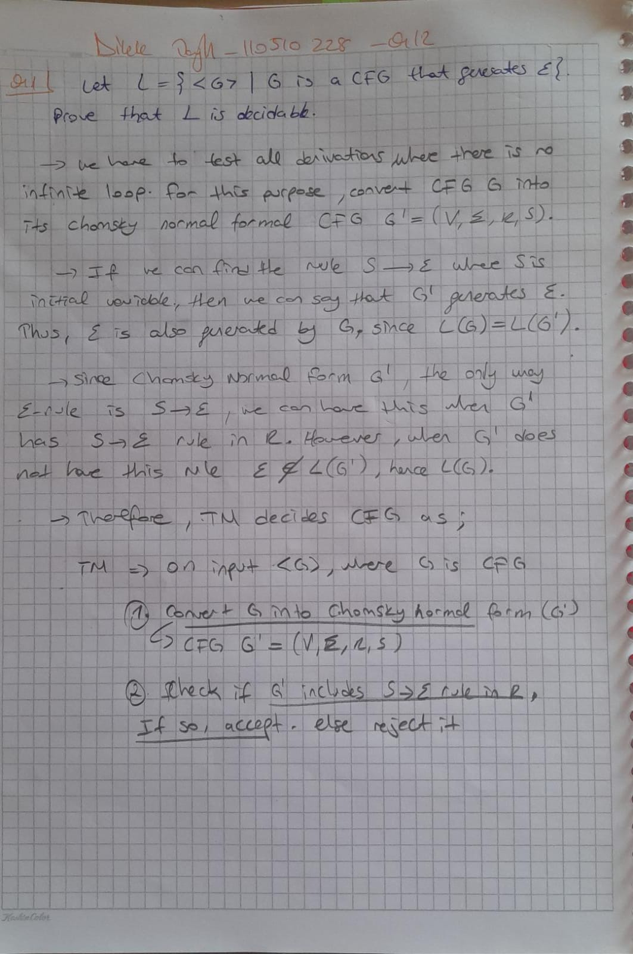Photo: